**AJAX**

DONE BY:

X.SHARON SWETHA

39120109

**1)**Write a program to retrieve a text file from the web server.

PROGRAM:

(HTML PAGE)

<!DOCTYPE html>

<html>

<body>

<div id="demo">

<h1>The XMLHttpRequest Object</h1>

<button type="button" onclick="loadDoc()">Change Content</button>

</div>

<script>

function loadDoc() {

const xhttp = new XMLHttpRequest(); xhttp.onreadystatechange = function() {

if (this.readyState == 4 && this.status == 200) {

document.getElementById("demo").innerHTML =this.responseText; }

};

xhttp.open("GET", "ajax.txt", true); xhttp.send();

}

</script>

</body>

</html>

(TEXT PAGE)

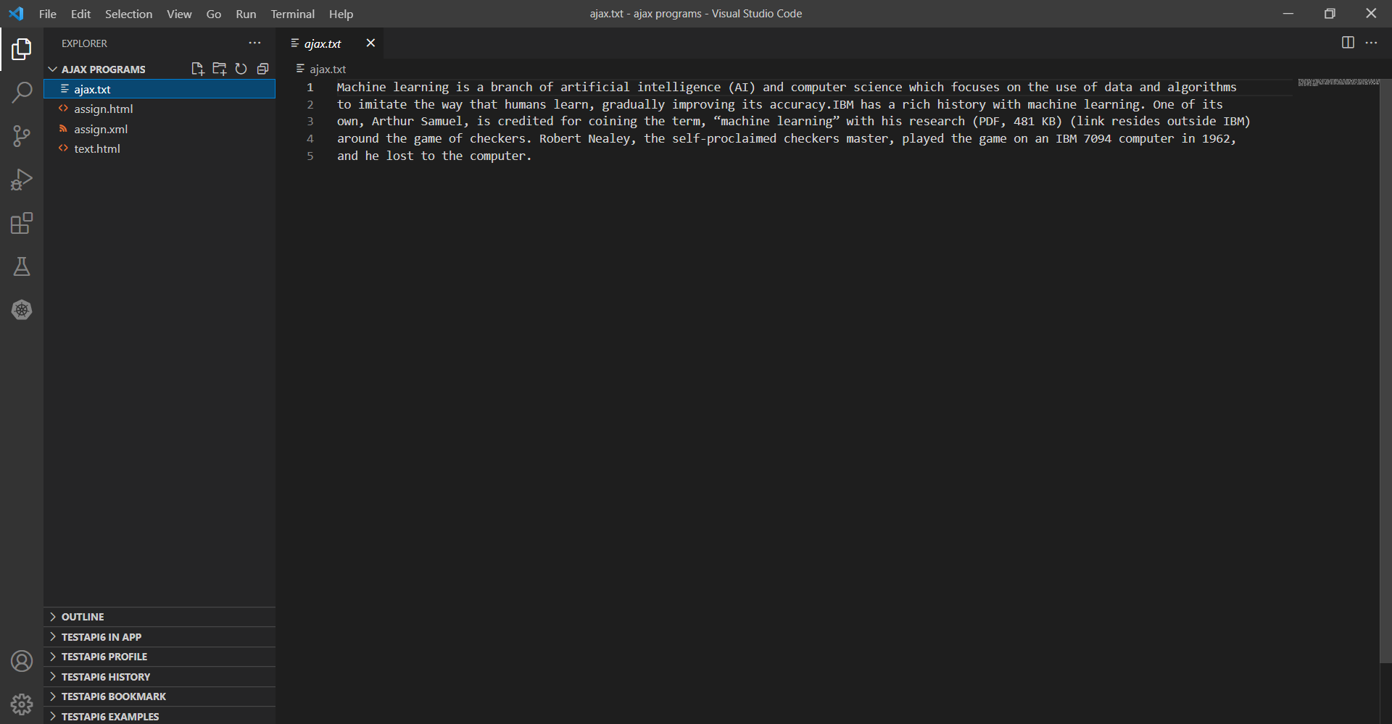

**OUTPUT**

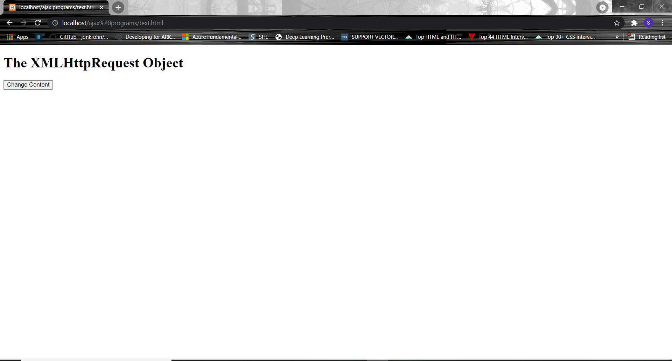

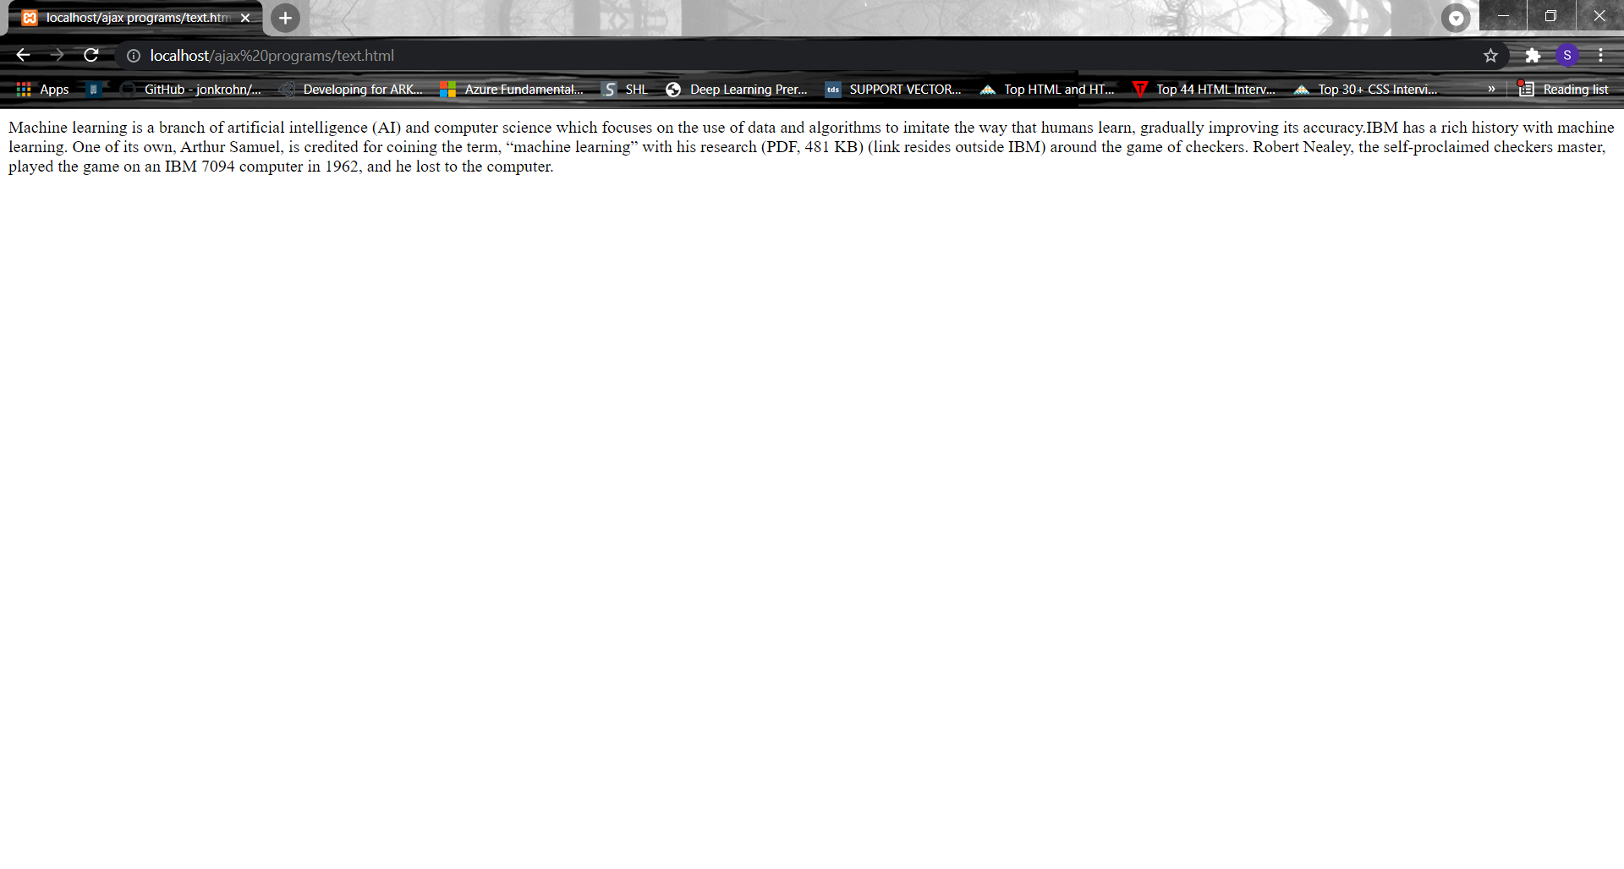**2)** Write a program to retrieve XML data from the webserver.

**HTML PAGE:**

<!DOCTYPE html>

<html>

<body bgcolor="FloralWhite">

<h1><center><font face="Arial">The XMLHttpRequest Object Form XML File</font></center></h1>

<p><b>Status: </b><span id ="A1"></span></p>

<p><b>Status Text: </b><span id ="A2"></span></p>

<p><b>Response: </b><span id ="A3"></span></p>

<button type="button" onclick="loadDoc('assign.xml')">Click here</button>

<script>

function loadDoc(url)

 {

var xhttp = new XMLHttpRequest();

xhttp.onreadystatechange = function()

 {

if (this.readyState == 4 && this.status == 200)

 {

document.getElementById("A1").innerHTML =this.status; document.getElementById("A2").innerHTML = this.statusText;

document.getElementById("A3").innerHTML = this.responseText; }

};

xhttp.open("GET", url , true);

xhttp.send();

}

</script>

</body>

</html>

**XML PAGE:**

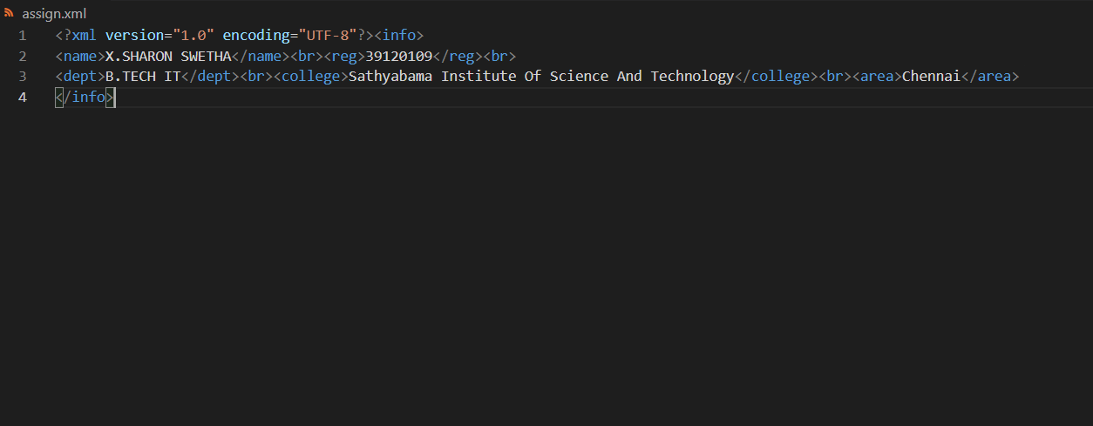

**OUTPUT**

